UNIVERSITY OF CALIFORNIA SAN DIEGO

RADY SCHOOL OF MANAGEMENT

QUALCOMMBUSINESS ANALYTICS CAPSTONE

**Final Report**



***The Qualcomm Chip Optimizers***

***Team Roles & Background***

**Sheena Taylor, Data Project Manager,**  brought her extensive background in data analytics and business strategy to lead the project's overall direction. Her ability to translate complex technical solutions into business value proved instrumental in stakeholder management and project success.

**Nick Shuckerow, Lead Machine Learning Engineer** whose expertise in Bayesian modeling and statistical theory shaped the project's analytical foundation. Nick's background in advanced mathematics and machine learning algorithms was crucial in developing our progressive elaboration features and model validation frameworks.

**Tony Woods, Data Scientist,** architected the Monte Carlo simulation framework that forms the backbone of our solution. His deep understanding of stochastic modeling and semiconductor manufacturing processes enabled the development of robust prediction algorithms.

**Fernando Santibanez, Full Stack Developer** bringing his expertise in software engineering and UX design to create an intuitive GUI interface. His background in probability distribution modeling and real-time validation systems ensured seamless user interaction with complex analytical tools.

**Bansari Kathrotia, Data Analyst** expertly managed data preprocessing and quality assurance. Her strong background in statistical analysis and attention to detail were vital in supporting model testing and maintaining comprehensive documentation.

***Manufacturing Excellence: A Deep Dive into Qualcomm's Semiconductor Operations***

**The Evolution of Semiconductor Manufacturing**

Semiconductor product development is one of the most challenging project management endeavors, requiring intense coordination across engineering teams and suppliers in a hard-to-predict environment shaped by the creation of novel products using cutting-edge technologies. At its foundation is wafer manufacturing, where chips are created in bulk through five main processes defined by Qualcomm:

* **Mask Set**: Creation of custom lithography tooling to define circuit patterns.
* **Fab**: Lithography, etching, and doping to build circuit layers on the wafer.
* **Bump**: Adding solder points for electrical connections.
* **Probe**: Functional testing of individual dies on the wafer.
* **DPS (Die Prep and Singulation)**: Cutting the individual chips (dies) off the wafer and preparing them for assembly.

Qualcomm operates a "fabless" model, where chips are designed in-house but the physical manufacturing processes are consigned through a network of external suppliers, allowing Qualcomm to focus on chip design, iterative refinement, and custom hardware/software to support performance testing. Qualcomm's internal labor is heavily involved in these steps, working both collaboratively with and concurrently to the suppliers through the manufacturing stages.

meaning Qualcomm does not own the foundries but instead focuses on designing chips and routing them through this supplier network. Qualcomm's internal efforts center on testing and evaluation, leveraging an iterative design process to refine product performance and developing custom hardware and software to support the probe stage.

Once the wafers are processed, multiple dies are combined with a custom circuit board into a package known as a **module**. This assembly item integrates custom-designed ASICs (application-specific integrated circuits) into a single, cohesive finished product. The assembled module must also be tested to evaluate holistic performance as individual chip performance can change when combined into a physical package.

**Manufacturing Variation**

**Production Planning and Prioritization**

Manufacturing prioritization follows a structured approach, with expedited levels ranging from Normal Level (NL) to Ultra High Level (UHL). This prioritization system enables efficient resource allocation while maintaining production quality standards. The processing options - Standard, Diced Wafer, and T&R (Test and Release) - provide standardized approaches to different production requirements. The Number_of_Wafers calculation system manages varying production quantities, demonstrating the manufacturing infrastructure's flexibility and scalability. This system accounts for different batch sizes and production requirements, ensuring efficient resource utilization across all manufacturing sites. The coordination of these elements requires sophisticated planning systems that consider both technical requirements and operational constraints.

**Data Infrastructure and Process**

Qualcomm's manufacturing data infrastructure captures and processes 26 key variables for each production cycle. This comprehensive data collection enables sophisticated analysis and modeling of manufacturing timelines. The manufacturing process's complexity requires careful coordination between different operational stages, supported by robust data collection and analysis systems.

**Table of Content**

**1. Advancing Semiconductor Manufacturing Through Data**

**2. Company Background**

**3. Problem Statement**

**4. Solution Design Summary**

**5. Solution Path**

**6. Data Source**

**7. Overview of the Workflow**

**8. Data Preparation & Exploratory Data Analysis (EDA)**

**9. Data Preprocessing**

**10. Simulation model Overview**

**12. Graphical User Interface (GUI) for Feature Input**

**13. Executive Summary**

**1. Advancing Semiconductor Manufacturing Through Data**

We have developed an innovative approach to semiconductor manufacturing optimization at Qualcomm. Our team brings together expertise in data science, manufacturing processes, and statistical analysis to create a sophisticated prediction framework for manufacturing timelines.

**2. Company Background**

Qualcomm stands as a global leader in wireless telecommunications technology.

The company's commitment to innovation extends beyond product development to manufacturing excellence, where the Experiential Analytics team drives continuous improvement through data-driven methodologies.

This extensive manufacturing network supports the production of cutting-edge semiconductor components that power modern telecommunications devices.

**3. Problem Statement**

Semiconductor manufacturing is one of the most intricate production processes due to its reliance on cutting-edge technologies and a vast chain of interconnected internal and external workflows. Predicting the time required to develop new semiconductor products is challenging, as each link in this extensive chain is subject to varying levels of volatility. This complexity is amplified in the development of modules, which are semiconductor packages containing multiple custom-designed subparts like unique chips and circuit boards. Each subpart undergoes its own iterative design cycles to achieve optimal performance, requiring custom hardware developed simultaneously. To minimize delivery timelines, this engineering work is conducted in parallel as much as possible, leading to multiple converging paths where the critical path—the sequence of tasks determining overall project duration—frequently shifts between projects. This dynamic and volatile nature makes accurate timeline forecasting for modules especially difficult.

The hard-to-predict nature of semiconductor module development, combined with a lack of robust analytics, leads to inaccurate planning that relies on intuition and subject matter expertise rather than data-driven insights. This imprecision creates two key issues: labor scheduling becomes inefficient, with downstream teams either over- or underutilized due to uncertainty about when their contributions will be needed. Current planning methods also enable overall development timelines to trend longer than targeted, driving excessive cost due to prolonged labor assigned to the project and adding risk that a competitor will be first to market.

**4. Solution Design Summary**

To effectively address the volatility and complexity of semiconductor development schedules, our team decided to construct a solution around Monte Carlo simulation. By running the project timeline thousands of times, with task durations randomly sampled from probabilistic distributions based on historical data, it captures variability and interprets it as a probability distribution of completion times. This approach helps program managers assess the likelihood of meeting deadlines and identify risks. In concurrent engineering, where multiple tasks are performed in parallel and interdependencies create variability, Monte Carlo provides critical insights into how changes in one part of the schedule can impact

the entire project.

To effectively simulate a product development schedule, it is crucial to accurately predict the duration of each individual task. Each task must be modeled using historical data that aligns with the specific characteristics of the product, as different product types can vary significantly in their completion times. To ensure precise modeling, we developed a sampling function within the simulation that runs for each task, filtering and predicting from only the relevant subset of data. By aligning task predictions with historical data that shares similar attributes, such as technology node or product type, the model achieves greater accuracy and reliability in reflecting real-world conditions. This targeted approach ensures the simulation produces realistic and actionable timeline predictions.

To enable users to interact seamlessly with the simulation and specify key product features, a user interface (UI) is essential. This UI acts as the bridge between the simulation's complex analytical backend and its practical application in daily operations. The UI also provides real-time feedback, guiding users to valid parameter combinations and allowing them to adjust inputs dynamically. This functionality empowers users to harness the full potential of the simulation without requiring advanced technical expertise.

By combining sophisticated analytical capabilities with user-centric design, our solution establishes a new standard for semiconductor development planning. This comprehensive approach improves prediction accuracy and reduces development timelines, but also enhances Qualcomm's ability to make strategic decisions in an increasingly complex and competitive landscape.

**5. Solution Path**

Our team developed a systematic approach to transform Qualcomm's semiconductor development timeline prediction from intuition-based to data-driven decision-making. The solution journey began with establishing a robust data foundation through comprehensive analysis of historical project timelines, identifying critical variables affecting development cycles, and implementing standardized data collection frameworks.

This initial phase ensures data quality and consistency, creating a reliable foundation for the predictive model.The model architecture phase focused on developing a sophisticated Monte Carlo simulation framework that incorporates probabilistic distribution modeling for task durations and complex dependency mapping systems. We prioritized creating an intuitive user interface to ensure accessibility for non-technical stakeholders, bridging the gap between advanced analytics and practical application.Validation and refinement formed the third crucial phase, where we rigorously tested the model against historical project data and gathered cross-functional stakeholder feedback. This iterative process allowed us to refine our algorithms and implement progressive elaboration capabilities, ensuring the model's predictions remained accurate and relevant throughout the project lifecycle.

The final implementation phase involved deploying the solution across pilot projects and establishing comprehensive monitoring protocols. We focused on training key stakeholders and creating effective feedback loops for continuous improvement.

This structured approach enabled us to deliver a robust, practical solution that addresses the core challenges of semiconductor development timeline prediction while maintaining the flexibility to adapt to evolving manufacturing complexities.

The resulting framework provides Qualcomm with powerful data-driven insights while ensuring practical usability across different manufacturing scenarios. By balancing technical excellence with operational practicality, we've created a sustainable solution that enhances Qualcomm's competitive advantage in semiconductor manufacturing and establishes a new standard for industry planning and optimization.

**6. Data Source**

The data used in this project originates from Qualcomm's semiconductor manufacturing processes, encompassing information across multiple process stages. The primary dataset includes detailed operational and production metrics, which serve as the foundation for predicting lead times and developing a simulation model. The following key attributes characterize the data:

1. **Source Description**:
   * The dataset contains production-level metrics captured from four process categories: **Maskset, Fab, Bump**, and **DPS**.
   * Each record represents a distinct production cycle, capturing various parameters such as:
     + **Process Category**: Indicates the specific manufacturing stage (e.g., Bump, Fab).
     + **Number of Wafers**: Represents the batch size of wafers in production.
     + **Expediting Priority**: Categorical levels (NL, HL, SHL, UHL) denoting the urgency of the lot.
     + **Cycle Timing Metrics**: Including lead time, queue time, and cycle time with their respective differences from target values.
     + **Platform and Site Details**: Descriptive identifiers for the platform and facility used in the production cycle.
2. **Data Collection Context**:
   * The data was collected over a specified timeframe and is representative of both typical and expedited production scenarios.
   * It integrates records from multiple production sites, ensuring diversity in production conditions and variability.
3. **Data Integrity and Challenges**:
   * The dataset contains some missing or null values (e.g., wafer counts in the Maskset process).
   * Variability across process categories and sites introduces inherent noise, which was addressed during data preparation.

This comprehensive dataset is integral to identifying patterns in production variability, building predictive models, and simulating lead times.

**7. Overview of the Workflow**

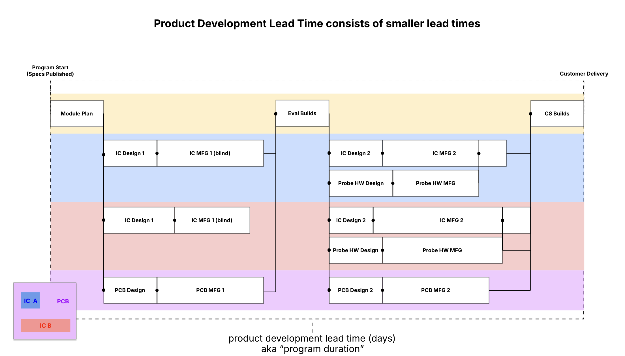

The workflow begins with **Program Start**, where specifications are published, and ends with **Customer Delivery**. Each phase is built around completing deliverables for **IC A**, **IC B**, and **PCB**, the three primary components. Tasks are categorized into **sequential phases** and **parallel tracks**, where dependencies ensure proper task alignment.

**7.1 Phases of the Workflow**

1. **Module Plan**:
   * High-level planning of resources and schedules.
   * Sets the foundation for the tasks that follow.
2. **IC Development** (for IC A and IC B):
   * Design → Manufacturing (MFG) → Probe Builds → Final Testing.
   * Two cycles of design and manufacturing ensure iterative improvement.
3. **PCB Development**:
   * Printed circuit board design and manufacturing are completed in parallel with IC development.
4. **Evaluation Builds**:
   * Assemble early versions of the module for physical performance testing
   * Combines IC and PCB builds to test overall functionality.
5. **CS Builds**:
   * The final stage includes assembly, customer-specific validation, and final testing.
   * Results in the CS “Customer Samples” date when the product is delivered to customer and timeline is complete

**7.2. Workflow Details**

1. **IC Development**

The development of integrated circuits follows a **two-cycle approach**:

* **IC Design 1** → **IC Manufacturing 1 (Blind Build)**:
  + Initial design and fabrication based on assumptions.
  + Blind builds identify performance issues in the design.
* **IC Design 2** → **IC Manufacturing 2**:
  + Improved designs based on feedback from the blind build.
  + Requires probe hardware design and manufacturing, enabling detailed testing.

1. **PCB Development**

The PCB tracks proceed simultaneously with IC development:

* **PCB Design**: Lays out the board to integrate ICs.
* **PCB MFG**: Fabricates the board once the design is complete.

**Evaluation and Testing**

* **Evaluation Builds**: Assembles ICs and PCBs for performance testing.
* **Dependencies**: Requires IC and PCB manufacturing to be complete.

**Customer Samples Builds (CS Builds)**

* Final assembly and testing ensure the product meets customer specifications.

**7.3. Dependencies**

Dependencies are the foundation of the workflow, dictating the order and timing of tasks. A task can only start once all its dependencies are completed.

1. **Sequential Dependencies**

* Tasks like **IC Design 1 → IC MFG 1 → IC Design 2** follow a clear progression.
* Dependencies ensure critical steps, like redesigns, incorporate feedback from earlier phases.

1. **Converging Paths**

* The two module build stages (eval and CS builds) are dependent on all preceding IC and PCB lead times to complete because we can’t build unless all parts are available.
* IC MFG 2 has a wafer probe lead time that cannot start unless the relevant probe solution has been completed.

1. **Parallel Tracks**

* IC A, IC B, and PCB tasks often run in parallel, reducing idle time.
* For example, while IC A|Design 1 progresses, IC B|Design 1 and PCB Design start independently.

1. **Critical Path**

* The longest chain of dependent tasks determines the total lead time.
* Bottlenecks, like delays in **Probe HW Design**, can impact the entire schedule.

**7.4. Workflow Alignment with Dependencies Table**

The dependencies table provides the detailed sequence of tasks reflected in the workflow:

* **Task ID**: Identifies specific tasks (e.g., ic_a|blind_build|design).
* **Deliverables and Segments**: Categorize tasks into their respective phases (e.g., blind build, probe build, CS builds).
* **Stages**: Represent specific steps within each segment (e.g., design, fabrication, testing).

**Key Examples:**

* ic_a|blind_build|design must finish before ic_a|blind_build|fab begins.
* Parallel tasks, like pcb|design and ic_b|blind_build|design, occur simultaneously, aligning with the workflow chart.

**7.5. Benefits of the Workflow**

The structured workflow and dependency mapping offer several benefits:

1. **Efficiency**:
   * Parallel tracks minimize idle time, optimizing resource use.
2. **Transparency**:
   * The workflow chart visualizes task progression and dependencies, making planning clear.
3. **Continuous Improvement**:
   * Iterative IC design cycles ensure issues are addressed early.
4. **Risk Management**:
   * Dependencies highlight potential bottlenecks, enabling proactive mitigation.

**8. Data Preparation & Exploratory Data Analysis (EDA)**

A robust exploratory data analysis (EDA) was performed to understand the dataset’s structure, identify patterns, and uncover insights that would inform the development of predictive models and simulations. The following subsections detail the specific analyses and observations made for key features, relationships, and variability within the dataset.

**8.1 Distribution of Lead Time Differences by Process Category**

To assess the variability in lead times, histograms were plotted for the lead time differences (target vs. actual) for each process category: Bump, DPS, Fab, and Maskset.

Key Observations:

1. Bump Process:
   * Mean lead time difference: 2.15 days.
   * Median lead time difference: 0.0 days, indicating that while the process sometimes runs late, half of the cycles meet or beat the target.
   * Standard deviation: 6.22 days, showing moderate variability.
   * The histogram highlights that most cycles are clustered near zero, with a slight tendency toward delays.
2. DPS Process:
   * Mean lead time difference: -0.51 days, indicating a slight tendency to finish earlier than the target.
   * Median lead time difference: -1.0 days, confirming this early tendency.
   * Standard deviation: 7.09 days, comparable to the Bump process.
   * The graph reveals a tight clustering near zero with occasional delays but a consistent bias toward early completion.
3. Fab Process:
   * Mean lead time difference: 2.07 days, highlighting regular delays.
   * Median lead time difference: 1.0 day, showing delays are more common than early completions.
   * Standard deviation: 8.99 days, the highest among all processes, indicating significant variability.
   * The histogram demonstrates a broad spread of delays, emphasizing the Fab process as the most unpredictable stage.
4. Maskset Process:
   * Mean lead time difference: -0.06 days, meaning it generally meets its target with minor deviations.
   * Median lead time difference: 0.0 days, confirming its consistency.
   * Standard deviation: 3.68 days, the lowest variability of all processes, making it the most predictable.

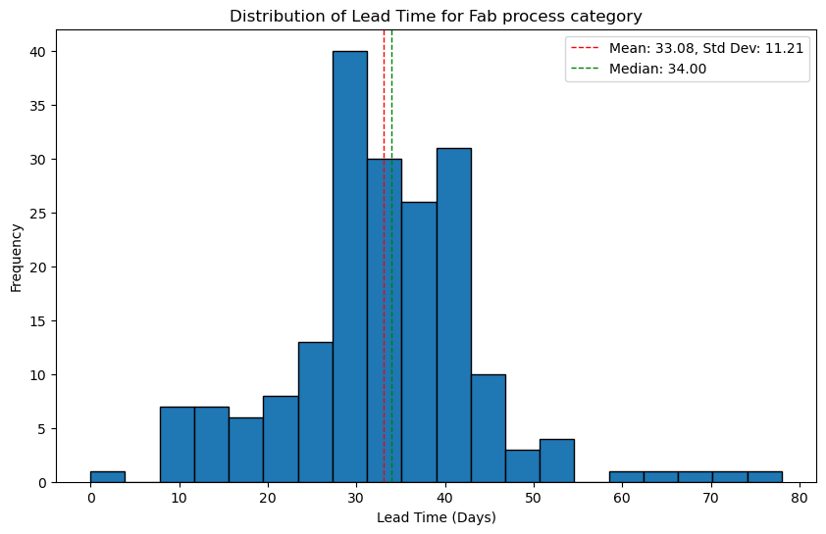

**8.2 Absolute Lead Time Differences**

To remove the directionality (early vs. late), absolute lead time differences were analyzed. These highlight the magnitude of deviations irrespective of whether they were delays or early completions.

Key Observations:

1. Fab Process:
   * Mean absolute lead time difference: 7.0 days.
   * The absolute deviations for Fab are significantly higher than other processes, reinforcing its status as the least predictable.
2. Other Processes:
   * Maskset: Lowest mean absolute difference (2.59 days), confirming its predictability.
   * Bump and DPS: Moderate absolute deviations (4.04 days and 5.04 days, respectively).

**8.3 Impact of Priority Levels**

The dataset included a categorical variable, expedite, representing priority levels (NL, HL, SHL, UHL). Bar charts comparing the mean and median lead times for each priority level within each process were created.

Key Observations:

1. Bump Process:
   * As the priority increases (from NL to UHL), the mean lead time decreases significantly:
     + NL: 11.77 days, UHL: 5.80 days.
   * The standard deviation also decreases, indicating that higher priority lots are processed more predictably.
2. DPS Process:
   * Similarly, higher-priority lots (e.g., UHL) show reduced mean lead times.
   * However, an anomaly was observed where UHL lots occasionally had longer delays than SHL, requiring further investigation.
3. Fab Process:
   * Significant reductions in lead time were observed as priority levels increased:
     + NL: 66.64 days, UHL: 27.58 days.
   * The Fab process benefited the most from prioritization.
4. Maskset Process:
   * Priority levels (where applicable) had minimal effect, likely due to the inherent predictability of this process.

**8.4 Relationship Between Number of Wafers and Lead Time**

Scatter plots were used to analyze the relationship between the number of wafers and average lead times for each process category.

Key Observations:

* Fab Process:
  + A clear positive correlation was observed: larger wafer batches led to longer lead times.
  + Outliers with extremely high lead times were associated with wafer counts above 15.
* Bump and DPS Processes:
  + Moderate increases in lead times were noted with higher wafer counts.
  + The trends were less pronounced compared to Fab.
* Maskset:
  + No significant relationship was observed, as Maskset does not use wafer count as a parameter.

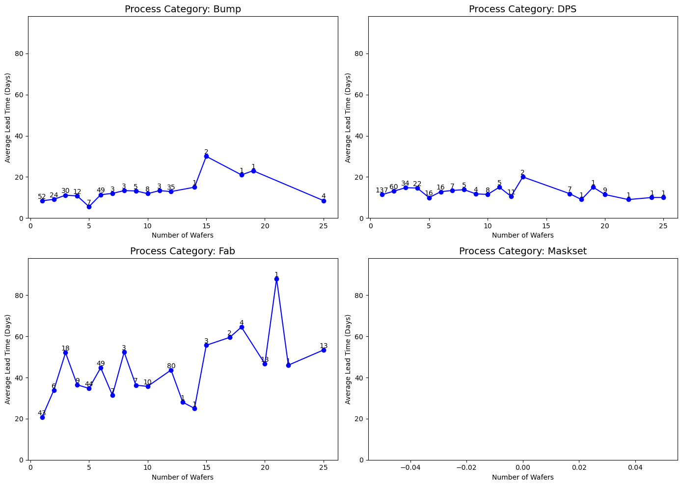

**9. Data Preprocessing:**

Before developing predictive models, the raw dataset underwent a comprehensive pre-processing phase to ensure data integrity, consistency, and readiness for analysis. The steps involved in pre-processing included:

* 1. **Loading and Preparing the Dataset**:
* The dataset was sourced from a CSV file containing production cycle data for various process categories and masksets.
* One key column, cycleout, representing the cycle completion date, was converted to a **datetime format** to enable accurate date-based operations and comparisons. This step ensures the data is standardized for time-based analysis.
  1. **Sorting and Filtering Records**:
* The dataset was sorted by three important attributes: **masksetname**, **processcategory**, and **cycleout** (earliest dates first). Sorting ensures chronological consistency, which is critical for analyzing trends and dependencies.
* For each unique combination of **masksetname** and **processcategory**, only the first (earliest) record was retained. This step ensures that duplicate or redundant records are removed, focusing the analysis on the first occurrence of each combination.
  1. **Deriving the Number of Wafers**:
* The dataset included a column, waferrange, which specifies the range of wafers (e.g., "1-25"). A custom function was applied to calculate the total number of wafers from this range:
* If the range was invalid or missing, the value was treated as **unknown (NaN)**.
* If the range was valid, the function calculated the total wafers as the difference between the start and end values plus one.
* Missing or invalid wafer counts were replaced with **0**, ensuring no disruption to downstream analysis or modeling.
  1. **Why These Steps Are Important**:
* **Data Integrity**: By converting cycleout into a proper format and filtering duplicate combinations, the dataset is cleaned and prepared for reliable analysis.
* **Feature Enhancement**: Deriving the Number_of_Wafers column enriches the dataset by adding a numeric variable directly relevant to modeling and predicting lead times.
* **Consistency**: Sorting ensures a clear order of records, while handling missing values ensures robust model performance without being affected by gaps in the data.

The pre-processed dataset provided a clean and structured foundation for feature selection, exploratory analysis, and model development, eliminating inconsistencies that could otherwise compromise the results.

**10. Simulation model Overview:**

The simulation model was developed as the primary solution to address Qualcomm’s need for predicting semiconductor product development timelines. Variability in task durations, dependencies among processes, and external factors often lead to bottlenecks and delays, creating significant challenges in production planning. The simulation uses probabilistic modeling to provide a range of possible outcomes, enabling stakeholders to understand risks, identify areas of improvement, and make informed decisions. By leveraging Monte Carlo simulations, the model accounts for uncertainty in task durations, respects task dependencies, and generates probabilistic distributions of project completion times.

The simulation model is designed to answer critical questions:

1. How do delays in specific tasks, such as Fab or DPS, propagate through the system?
2. What is the likelihood of completing a project within a given timeframe?
3. Which processes are bottlenecks, and how can we mitigate their impact?

By addressing these questions, the model provides a foundation for effective resource allocation, priority adjustments, and long-term production optimization.

* 1. **Data Structure:**

The historical dataset, which records lead times, wafer counts, priority levels, and process categories, underwent extensive preprocessing to ensure reliability. Raw data often contained missing values, inconsistencies, and outliers that could skew results. Therefore, the preprocessing steps included:

* Cleaning and Normalization: Missing values in critical columns, such as leadtime, were addressed by imputing or removing rows. For example, missing Number_of_Wafers entries for Maskset were replaced with zeros since this process does not utilize wafers.
* Feature Engineering: New features, such as absolute lead time differences and categorical encodings, were created to enhance the dataset’s predictive power. Wafer counts were derived from ranges, converting strings like "1-25" into numerical values.

This cleaned and enriched dataset provided the foundation for generating probabilistic task durations and mapping dependencies.

* 1. **Relational Database for Task Dependency Mapping:**

The simulation required a relational database to enforce task dependencies. Each task (e.g., Fab, Maskset) was assigned predecessors and successors, reflecting the real-world workflow. The database design enabled:

1. Critical Path Identification: The Fab process consistently appeared on the critical path due to its long and variable lead times.
2. Concurrent Task Handling: Processes that could run in parallel, such as Maskset and Bump, were modeled to optimize sequencing.
3. Dynamic Querying: The relational database structure allowed flexible querying, critical for adjusting task sequences during simulations.

These dependencies were translated into a directed acyclic graph (DAG) to sequence tasks accurately.

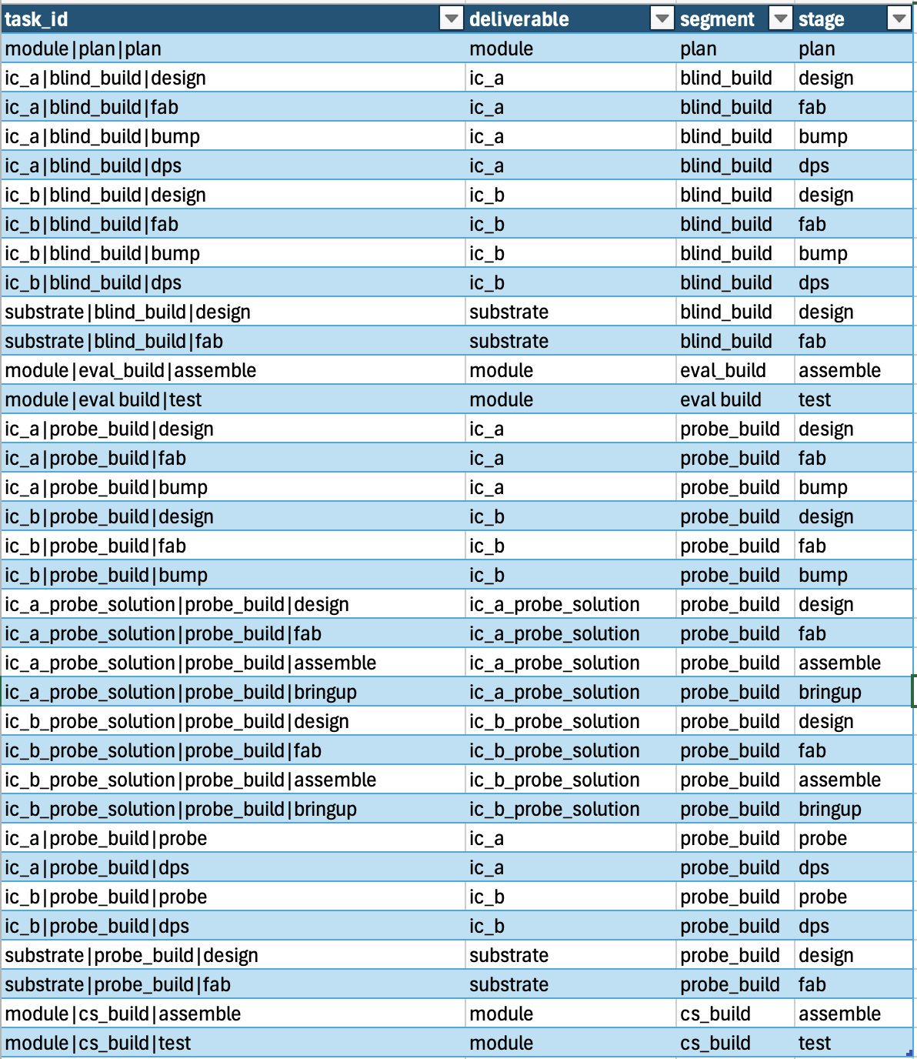

* 1. **Simulation Methodology:**

User Interaction and Input Parameters

The simulation was designed to be user-friendly, allowing stakeholders to input parameters such as:

* Product characteristics: wafer counts, technology nodes, and process categories.
* Priority levels: normal, hot, super hot, and ultra hot lots.
* Timeline constraints: target durations and snapshot days for progressive refinement.

These inputs tailored the simulation to real-world scenarios, ensuring that predictions aligned with Qualcomm’s operational needs.

The stepping order ensured that tasks followed their logical sequence, respecting dependencies. For example, the Fab process must be completed before DPS begins. By enforcing this order, the simulation avoided unrealistic overlaps or out-of-order execution. The stepping order was essential for generating accurate Gantt charts and project timelines.

* 1. **Simulation Execution:**

Each simulation run consisted of the following steps:

1. Assigning Probabilistic Durations: Task durations were sampled from probabilistic distributions derived from historical data. For example, the Fab process followed a normal distribution with high variability, reflecting its real-world unpredictability.
2. Sequencing Tasks: The DAG was used to determine the sequence of tasks based on dependencies.
3. Recording Results: Each run generated a total project duration, contributing to a distribution of possible outcomes.

The Monte Carlo approach allowed for thousands of iterations, capturing the full range of variability. For example, the baseline scenario revealed a wide distribution of project timelines, with a median of 150 days and a significant probability of delays beyond the target timeline.

* 1. **Progressive Elaboration:**

Progressive elaboration refined predictions as the project progressed. Early tasks, once completed, were treated as fixed, reducing uncertainty for downstream processes. For example, after completing the Maskset process, variability in Fab lead times became the primary source of uncertainty. This iterative refinement narrowed the range of possible outcomes, improving accuracy over time.

* 1. **Interpretability:**

Gantt Chart Visualization

Gantt charts provided a detailed view of individual simulation runs, showing task sequences, durations, and dependencies. For example, a baseline run might highlight delays in the Fab process, pushing DPS and Bump timelines further into the future. These charts enabled stakeholders to pinpoint bottlenecks and assess their impact.

Density Chart Visualization

Density charts aggregated results across all runs, showing the distribution of project completion times. These charts highlighted trends and variability, making it easier to assess overall risk. For example, the baseline scenario density chart revealed a long tail of delays, emphasizing the need for Fab process optimizations.

* 1. **Potential for Expansion: Bayesian Ridge Model:**

While the simulation model excels at capturing macro-level variability and dependencies, it relies on static distributions derived from historical averages. Our team attempted to use a Bayesian Ridge Regression model to predict both the mean and standard deviation of each task the user would input. Unlike normal prediction models, Bayesian Ridge Regression can have outputs of both mean and standard deviation for each prediction.

Although the model produced an R-Squared of 0.8, the mean and especially the standard deviations were inaccurate compared to actual groupings of historical data. The Bayesian Ridge model is the start of developing a model which can predict not solely historical distributions, but new tasks and processes with unique combinations of the features. As such, our simulation is limited to only combinations of features for each task that are within the historical data.

Below shows the comparison between the historical mean lead times and their standard deviations compared to those predicted from the Bayesian ridge model. The Bayesian ridge estimates are significantly off compared to the historical on most of the top 15 data points with the highest counts. This is only exacerbated when predictions occur for combinations with lower counts of data points.

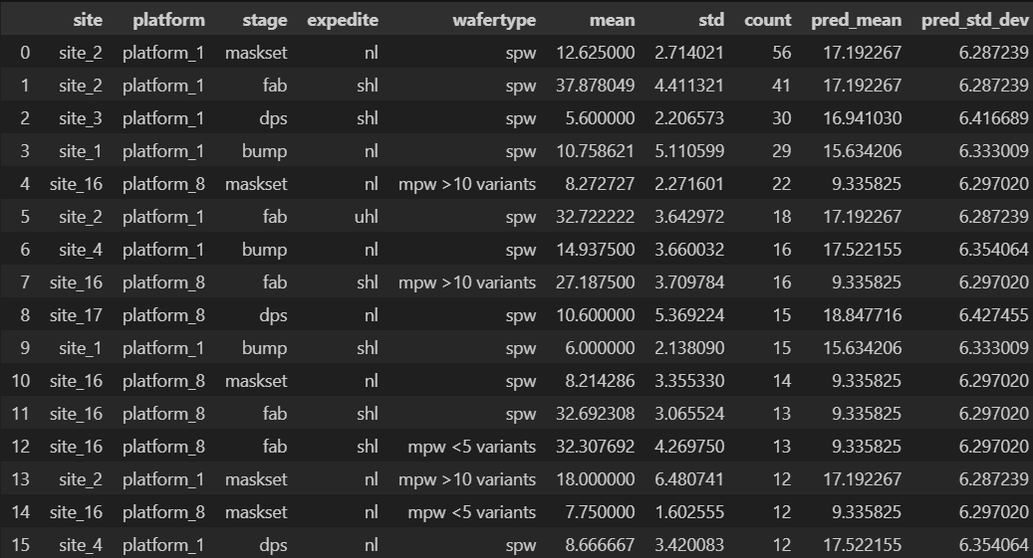

**11. Simulation Results: Insights from Grouped Data**

The simulation results were derived using aggregated data on task durations, dependencies, and variability. The grouped data provided crucial metrics—mean, minimum, and maximum durations for each task or segment—allowing for a deeper understanding of process bottlenecks, variability, and areas of potential improvement.

**11.1 Key Task Metrics:**

The simulation outputs included grouped statistics for critical tasks such as Fab, DPS, Assembly, and Design. For each task, the mean duration represents the expected time for completion, while the min and max durations highlight variability and potential delays. These metrics help identify:

* High-Variability Processes: Tasks where the difference between max and min durations is significant, indicating unpredictability.
* Stable Processes: Tasks with consistent durations across simulations, suggesting lower risks of delay.

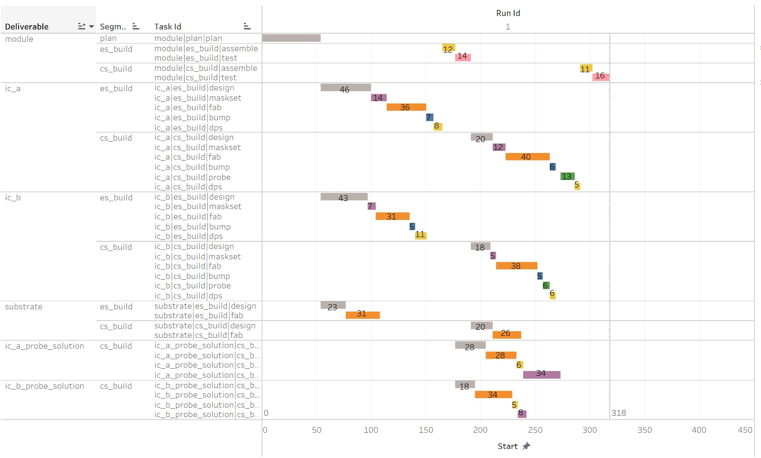

**11.2 Example Insights from Data:**

* The Fab process under probe_build had a mean duration of 21.9 days, with variability ranging from 11 days (min) to 31 days (max). This variability places it among the most unpredictable processes, reinforcing its role as a bottleneck in the critical path.
* The Bump process under blind_build displayed less variability, with a mean of 23.5 days and a range from 8 days (min) to 33 days (max).
* Assembly tasks under cs_build were among the most stable, with a mean duration of 24.3 days and a narrower variability range of 16 to 37 days.

**11.3 Identifying Bottlenecks:**

The simulation revealed that tasks with higher mean durations and significant variability disproportionately impacted the total project timeline. Specifically:

1. Fab (probe_build):
   * Contributed significantly to project delays due to its high mean duration (21.9 days) and variability (range of 20 days between min and max durations).
   * Mitigating delays in this process, such as by increasing capacity or reducing variability, could yield substantial improvements in overall timelines.
2. DPS (probe_build):
   * Displayed a mean duration of 20.5 days with variability from 9 days (min) to 28 days (max).
   * Though not as variable as Fab, its relatively long mean duration still made it a critical contributor to delays in the production workflow.
3. Assembly (cs_build):
   * Exhibited stability with minimal variability but contributed to delays due to its consistently high mean duration (24.3 days).
   * Improvements in parallel task execution or resource allocation could help reduce its timeline impact.

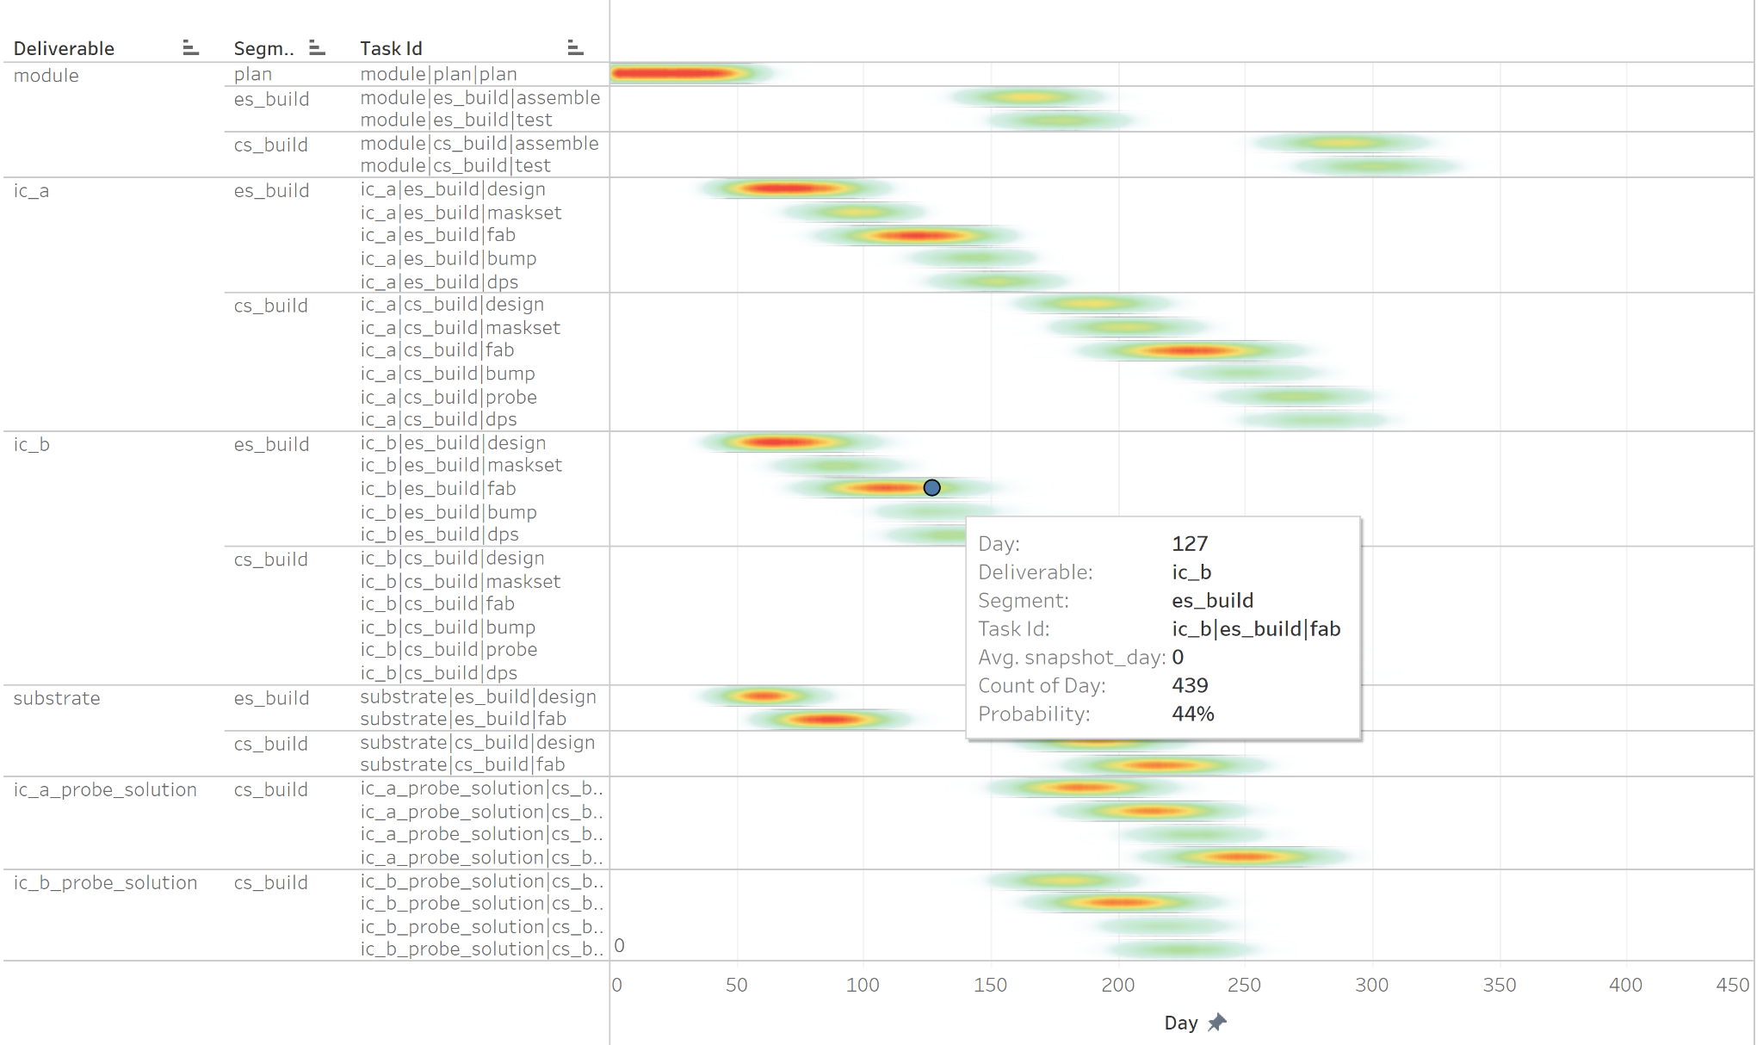

**11.4 Process Stability:**

Tasks such as Evaluation (eval_build) and Plan (plan_build) were identified as stable processes. These tasks had low variability in durations, with ranges of only 3 to 4 days between their min and max durations. Their stability makes them less risky and unlikely to contribute significantly to delays. For instance:

* Plan (plan_build):
  + Mean duration: 17.5 days.
  + Variability: Low, ranging from 6 days (min) to 28 days (max).
* Evaluation (eval_build):
  + Mean duration: 20.2 days.
  + Variability: Narrow, with durations ranging from 10 days (min) to 30 days (max).

These processes offer opportunities for resource reallocation, as their low risk allows for a focus on more variable and time-intensive tasks like Fab or DPS.

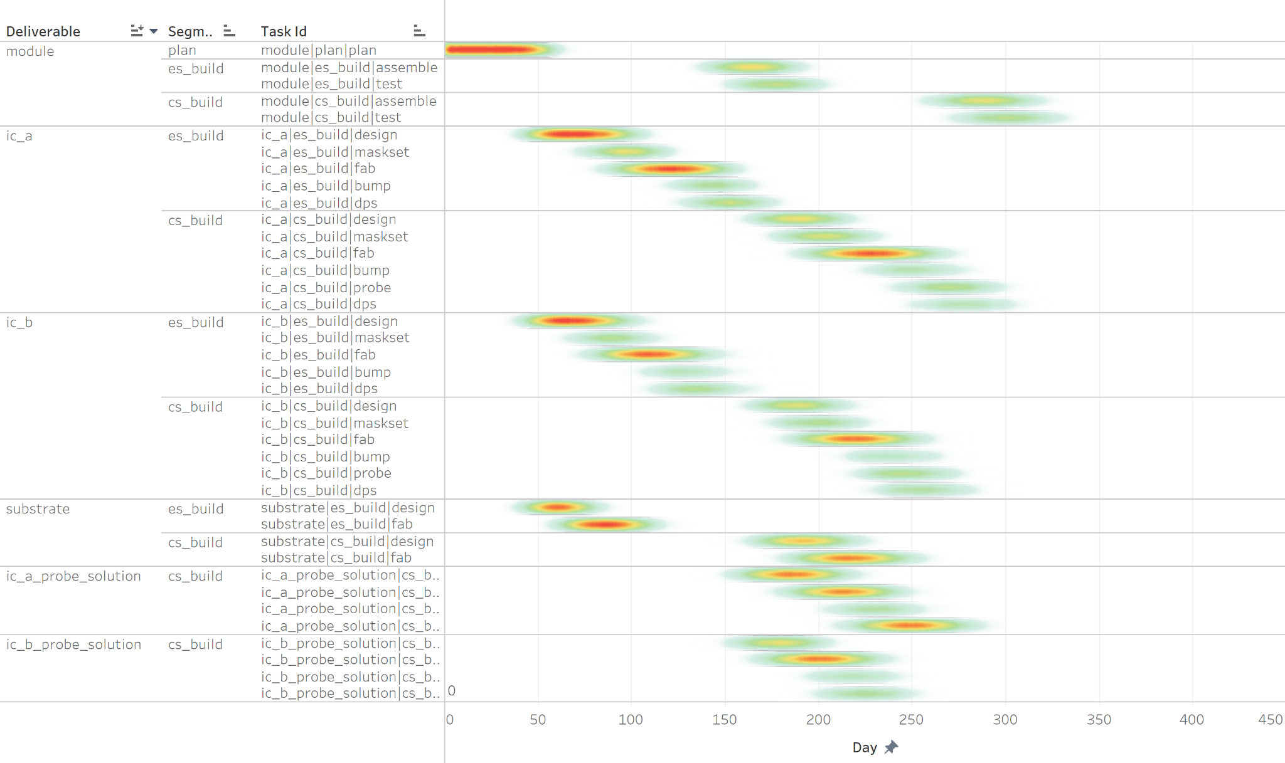

**11.5 Visualization of Results:**

To support interpretability, the simulation results were visualized using:

1. Bar Charts: Comparing mean durations for tasks across segments (e.g., Fab, Assembly, Bump).
2. Box Plots: Showing variability (min-to-max range) in task durations for key bottlenecks like Fab and DPS.
3. Heatmaps: Highlighting processes with the highest variability and their contributions to project delays.

The insights from the grouped simulation outputs directly inform Qualcomm’s strategy for improving production efficiency:

1. Bottleneck Mitigation:
   * Targeting high-variability processes like Fab for capacity increases or variability reduction can significantly reduce overall timelines.
2. Resource Allocation:
   * Stable processes such as Planning and Evaluation require less oversight, allowing resources to be redirected to critical areas.
3. Scenario Testing:
   * By simulating "what-if" scenarios, the impact of prioritizing high-risk tasks or adding capacity to Fab can be quantitatively assessed.

These insights reinforce the simulation model’s role as a primary decision-making tool, guiding Qualcomm toward more efficient and predictable production workflows.

**12. Graphical User Interface (GUI) for Feature Input**

A **Graphical User Interface (GUI)** was developed using Python’s **Tkinter library to facilitate user interaction and streamline the feature selection process for manufacturing tasks**. This GUI aims to enable users to input the required feature values for each task in the manufacturing workflow while ensuring data integrity through built-in validations. These inputs are crucial as they determine the distributions and historical patterns used in the simulation model.

**12.1 Design and Layout**

The GUI is structured to accommodate five major features for each task in the manufacturing process:

1. **Stage**: Represents the fixed sequence of manufacturing stages—Maskset, Fab, Bump, and DPS.
2. **Platform**: Denotes the platform where the task is executed.
3. **Site**: Refers to the specific production site.
4. **Expedite**: Captures the priority level of the task (e.g., NL, HL, SHL, or UHL).
5. **Wafertype**: Indicates the type of wafers used, such as SPW or MPW.

On the left-hand side of the GUI, the **Stage** column is static since all builds follow the fixed sequence of Maskset, Fab, Bump, and DPS. As users move from left to right in the GUI, selecting values from dropdown menus, the subsequent columns dynamically filter the available options based on historical constraints. For instance, if the user selects "Bump" for the stage, the dropdown for "Platform" automatically excludes options that were not historically associated with the Bump stage.

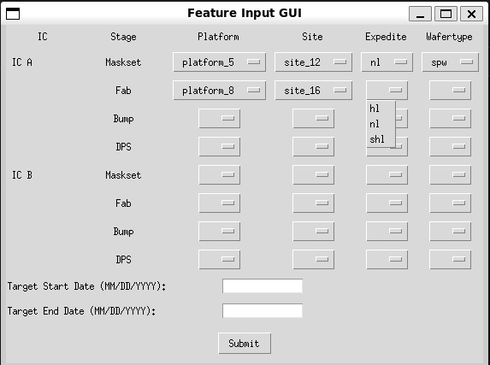

**12.2 User Inputs**

At the bottom of the GUI, users are required to input:

1. **Target Start Date** and **Target End Date**: These fields are used to calculate the target duration for the simulation. This target duration helps determine the probability distribution of completing the process within the specified timeframe.

The interface includes multiple safeguards to prevent invalid inputs. For example:

* Users cannot submit the form without completing all fields.
* The GUI validates the date format and ensures logical consistency (e.g., the end date must occur after the start date).

If any errors are detected, appropriate error messages are displayed to guide the user in correcting their input.

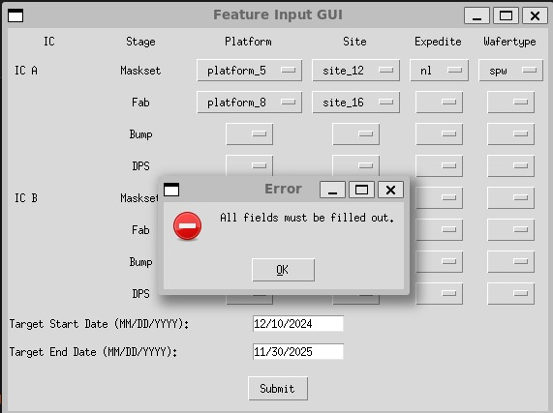

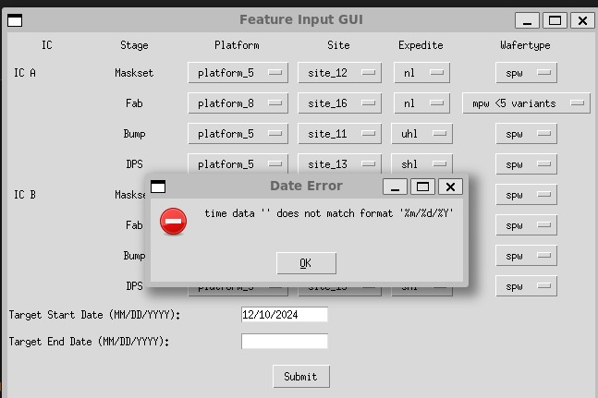

**12.3 Functionality and Workflow**

1. **Dynamic Filtering**:
   * Each dropdown menu dynamically adjusts based on prior selections. This ensures that users only see valid combinations, improving usability and reducing the risk of errors.
   * For instance, if no Bump stages took place on Platform 8 in the historical data, Platform 8 will not appear as an option in the "Platform" column for the Bump stage.
2. **Error Handling**:
   * The GUI prevents submission if any field is left blank.
   * Errors are flagged with clear, descriptive messages, ensuring users understand what needs correction. Examples include:
     + "All fields must be filled out."
     + "Time data does not match format MM/DD/YYYY."
3. **Submission and Results**:
   * Upon successful submission, the application calculates the duration between the start and end dates and integrates the input data into the simulation model. The user is presented with a confirmation message showing the computed duration and confirming that the data has been successfully submitted.

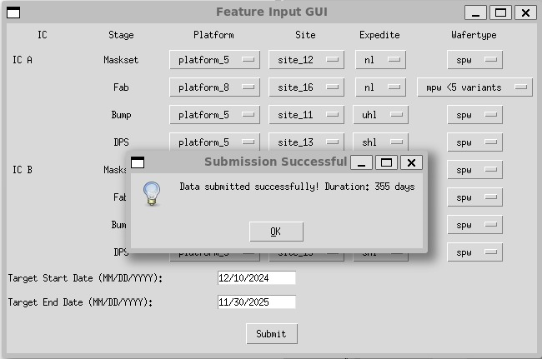

**Integration with the Simulation Model**

The data collected through the GUI serves as the input for the simulation model. By linking user-defined inputs to historical distributions, the model simulates the manufacturing process with realistic constraints and variability. This integration ensures that the simulation reflects the user's specific scenarios and priorities, enabling tailored insights for decision-making.

**13. Executive Summary**

**Semiconductor Product Development Time Prediction Analysis**

Our team has developed a sophisticated Monte Carlo simulation model to predict semiconductor product development timelines, addressing a critical need in the industry for accurate project planning and risk assessment. This solution combines historical data analysis, probabilistic modeling, and dynamic task dependency mapping to provide reliable predictions for complex development cycles.

The core architecture consists of three primary components. First, a robust data preprocessing framework that cleanses and categorizes historical task data to establish accurate probability distributions. Second, a relational database that maps intricate task dependencies, ensuring real-world workflow constraints are maintained. Third, an intuitive user interface that allows non-technical stakeholders to interact with the simulation effectively.

Our simulation methodology employs a sophisticated stepping order algorithm that respects task dependencies while generating project schedules. Each simulation run produces a complete project timeline by assigning probabilistic durations based on product-specific attributes.

The model incorporates progressive elaboration, allowing for continuous refinement of predictions as projects advance. This feature has proven particularly valuable for adapting to real-world project dynamics and improving prediction accuracy over time.

For result interpretation, we've implemented dual visualization approaches: detailed Gantt charts for individual simulation runs and density charts that aggregate results across multiple iterations. This combination provides stakeholders with both granular insights and high-level trend analysis capabilities.

Looking forward, we've identified Bayesian modeling as a promising enhancement to our current framework. This approach would better handle rare product types and scenarios with limited historical data, while providing more nuanced confidence intervals for predictions.

While our current model demonstrates strong predictive capabilities, implementing Bayesian methods would require additional feature development and data collection to achieve optimal results.

The model has successfully demonstrated its ability to predict development timelines with increased accuracy compared to traditional methods. However, we acknowledge certain limitations, particularly in handling edge cases and newer product types.

Our team recommends continued development focusing on Bayesian implementation and expanded feature sets to enhance prediction accuracy further.

**13.2 Key Metrics to Track**

**Labor Planning and Cost Savings Optimization**

Our simulation model reveals significant opportunities for labor cost reduction and efficiency improvements in semiconductor product development. By analyzing resource utilization rates, task duration patterns, and critical path labor distribution, we project potential annual savings through strategic optimization initiatives.

The model identifies that current resource utilization averages, suggesting room for improvement to reach the optimal target. By implementing dynamic resource allocation based on simulation predictions. Skills-based task assignment, informed by our simulation data, shows potential for reducing training and ramp-up times by matching employee expertise with specific task requirements.s. Additionally, our analysis of parallel task opportunities suggests that optimizing concurrent workflows could save. These findings emphasize the value of using simulation-based insights for workforce planning and cost management. Regular quarterly reviews of these metrics and continuous refinement of the model will ensure sustained optimization of labor resources and maintenance of cost savings over time.

**APPENDIX (PYTHON CODE)**

